ROYAL NAVY & ROYAL MARINES CYCLING ASSOCIATION
www.navycycling.org.uk

 | 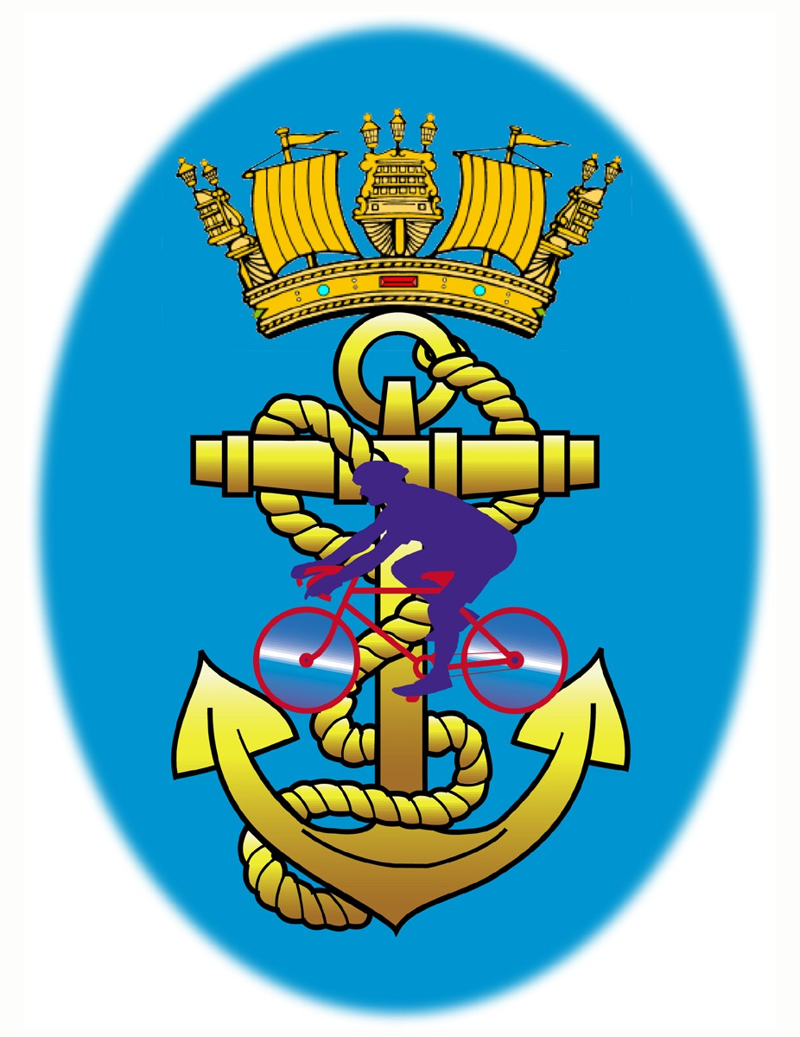 | Barry Moss  9 Broomfield Drive  Hooe  Plymouth  DEVON  PL9 9PG  Tel: 07881900519  barrymoss2@hotmail.co.uk

ROYAL NAVY & ROYAL MARINES CYCLING ASSOCIATION

Presents an

Open 10 Mile Time Trial

Promoted for and on behalf of the Cycling Time Trials under their Rules and Regulations.
On Wednesday 30th Jun 2021 at Buckfastleigh, Devon.

Timekeepers: Events: Event Secretary:
Start – Mr Ken Robertson RNRMCA members Mr Barry Moss
Finish – Mr Ian Myers & Families 9 Broomfield drive
Hooe
Plymouth
PL9 9PG
Tel: 01752 481127
Mob: 07881900519

RNRMCA 10M TT on S4/10 – Wed 30th Jun 2021

Thank you all for choosing to ride this year’s RNRMCA 10M OPEN TT. I would like to thank all the helpers who assisted me on the evening in making the event run smoothly. It was particularly pleasing to see so many RNRMCA riders participating, some travelling quite some distance in doing so. The men’s event saw MDCC rider Donald Brooks set the fastest time of the night in a time of 19:15, followed by RAF CA rider Rob Willcocks clocking 19:32, 3rd saw the first RNRMCA rider with Josh Clarke at 19:34. In the ladies event we saw the course record smashed by Avid Sport rider Tamsin Miller, set a new best time of 20:40, Nicki Carr, Tri UK was second in 22:28, with the RNRMCA rider Lauren Parker in third at 23:58.

1st Man – Donald Brooks (MDCC), 2nd Robert Willcocks (RAF CA), 3rd Man – Josh Clarke(RNRMCA)

1st Lady – Tamsin Miller (Avid Sport) (New Course Record 20:40), 2nd Lady – Nicki Carr (Tri UK), 3rd Lady – Lauren Parker (RNRMCA)

1st Vet 40-44 – Thomas Fraser (RNRMCA)

1st Vet 45-49 – Andrew Perkins (MDCC)

1st Vet 50-59 – Gavin MacDougall (RNRMCA)

1st Vet 60 – Mark Sanders (MDCC)

1st Lady Vet – Maria Weymouth (MDCC)

Please note: One Rider One Prize – If you are named above, please email barrymoss2@hotmail.co.uk with your bank details and I will transfer your prize money. If you would like to donate your prize money, I am collecting for Shekinah Mission in Plymouth. If you would like more info on the amazing job they do, please check out: www.shekinah.co.uk . Let me know and I will add it to the £40 already raised on the night.

